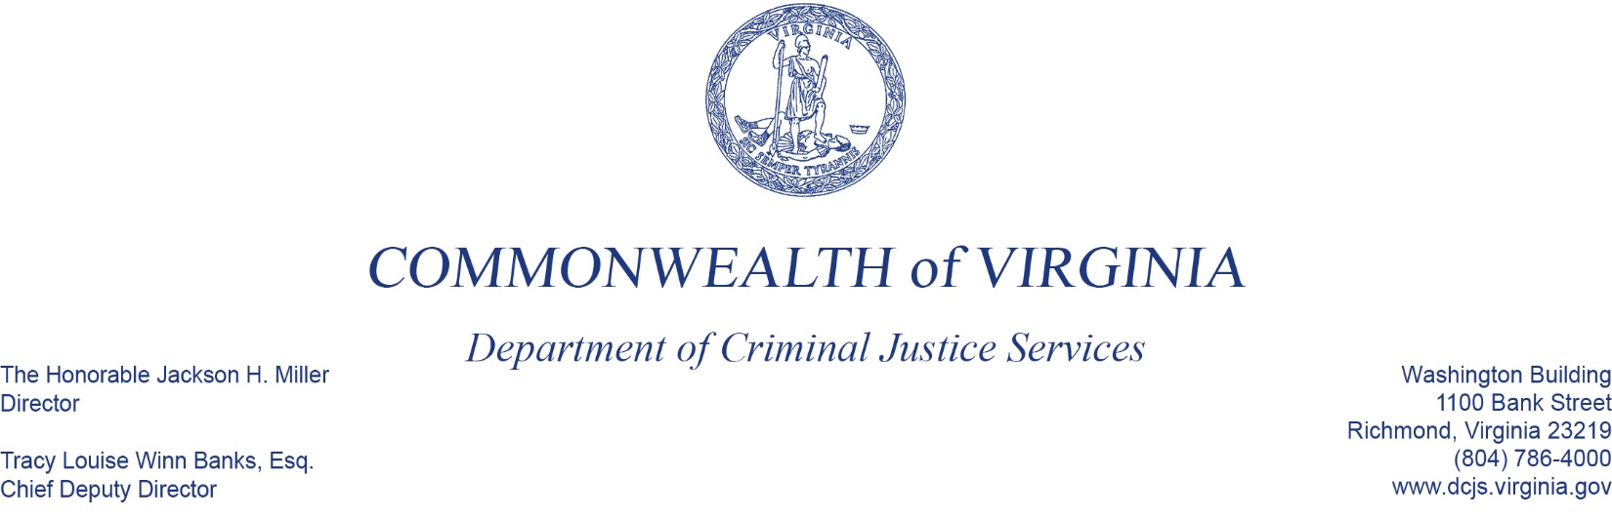
To: Criminal Justice Services Board Grants Committee
From: Tracy Matthews, Law Enforcement Training and Grants Supervisor, Acting Manager
Date: June 2, 2022
Re: FY23 Hate Crimes Grant Program

Today you have before you the proposed budget for the Combatting Hate Crimes Grant Program for FY23, totaling $44,500, which will provide funding for one (1) grantee. This is the third roll out of this funding.
The funding supports localities, who have or will partner with non-profit organizations or institutions that have been targets of or are at risk of being targeted for hate crimes. This was the only application received for this funding opportunity.
If approved, staff will work with this grantee to revise and resubmit their budget to ensure the target population for this grant will benefit directly from the proposed project.
This is a one-time award to this locality, scheduled to end on March 30, 2023, unless additional funding is made available in future budget cycles.
The agency has plans to release another solicitation in the near future, to utilize the remaining funding allocated for this program.

